Design, Manufacture, and Implementation of the Anderson Firearms Model “GhostFire”



A Guide by Anderson D. Nguyen

September 2, 2019



*This document is dedicated to the CCP,*

*Because fuck the CCP. Try and ban this fuckers.*

Table of Contents

Disclaimer………………………………………………4

Design Use Intent………………………………………5

Testing and Reliance on 3D Printed Lower……………6

Materials and Tools…………………………………….10

Manufacturing………………………………………….12

Assembly……………………………………………….15

Implementation…………………………………………26

Sources and Citations…………………………………..28

Disclaimer

It goes without saying that I am not responsible for any injuries, deaths, or accidental discharges caused by this 3D printed firearm. Print and assemble at your own peril. What I can say though is that if you read through this document I have personally printed, designed, and tested this model to ensure that anyone who attempts to replicate it will not face catastrophic failures (explosions) assuming you followed the instructions and have not fired beyond 150 rounds (because that’s all the ammo I had at the time to test it with).

It also goes without saying that I am not responsible for deaths caused by this firearm through the means of mass shootings, rampages, insurgencies, general unrest, personal defense, home defense, ect. That’s like saying Kalashnikov should be held responsible for the +60 million deaths caused by his AK-47 design, or John Browning for the +20 million deaths. What you do with this knowledge or firearm is your own personal decision, and like all freedoms we have in these United States also comes with great responsibilities. Your right to bear arms doesn’t justify you walking into a Walmart in El Paso to gun people down for being brown. As a matter of fact, I would argue that had anyone in that store had a gun there wouldn’t be a mass shooting. It would have been one dead idiot with an overheated WASR-10 and a hero who stopped a shooting, but that didn’t happen cause of gun laws right?

THIS IS AN OPEN SOURCE DESIGN. ANYONE WHO TRIES TO SELL YOU THIS SHIT IS FUCKING WITH YOU. Make sure to follow your local gun laws, unless you live in Commie-Fornia, where people are denied the right to self-preservation of life and limb. THIS DESIGN IS FREE AND EASILY OBTAINABLE.

Design Use Intent

The purpose of this design and model is to implement an AR-15 Lower Receiver capable of reliable fire on demand in PLA. Previously, it is highly inadvisable to shoot any 3D printed firearm in PLA. While PLA is more durable than ABS, PLA doesn’t perform well under heat, and is not designed to take rapid sharp impacts. In other words, PLA is mainly for showcasing and model designs that do not function or have moving parts. Without designing the entire lower from scratch for the purpose of withstanding repeated rapid forces, plastic will not survive... Ever. Thus, the Anderson Firearms Model “GhostFire,” was designed by me to overcome this barrier to firearms.

The reasoning for the development of 3D Printed firearms is the same reason FOSSCAD exists: One way or the other, 3D printing technology and technology in general will exist and surpass beyond control of Governments or entities of power. You can pass all kinds of laws and rules to control the flow and manufacturing of firearms, but you can never control or obtain control of the most intimate resource a person can have: Autonomy of thought. If all firearms and the knowledge of firearms were to instantly disappear across the whole world, the very next day millions of firearms would yet again be produced and distributed. Guns are here to stay. Wake up from your delusions. All gun legislations are infringements. All gun control is more like people control than actual gun control. Notice how when gun laws are passed its usually law-abiding citizens who pay the price? I know, been there done that. Even if the Feds were to storm my house right now and take my firearms, they can’t possibly control what’s in my head. The moment they confiscate my arms, I will have already memorized every part by heart, every component committed to memory, and the very next day I will yet again obtain another AR.

Testing and Reliance on 3D Printed Lowers

All parts are to be printed in either PLA or ABS. While the model has been tested and designed specifically for PLA, ABS is a far more practical choice in general for 3D printed firearms due to its heat resistance, flexibility, and durability under stress. However, the model does in fact work perfectly fine in PLA. That said, this section is specifically here to let you folks know, that it can be nerve wrecking to shoot a rifle (intermediate) cartridge out of plastic made parts. Hence why I made this section: I wouldn’t distribute any files online without testing it myself. To guarantee your safety in discharging 5.56 or .223 Rem out of a PLA lower, I went through the trouble of doing the test myself. What follows is a 2-day testing regime where I tested different variants of the GhostFire model.

August 29, 2019

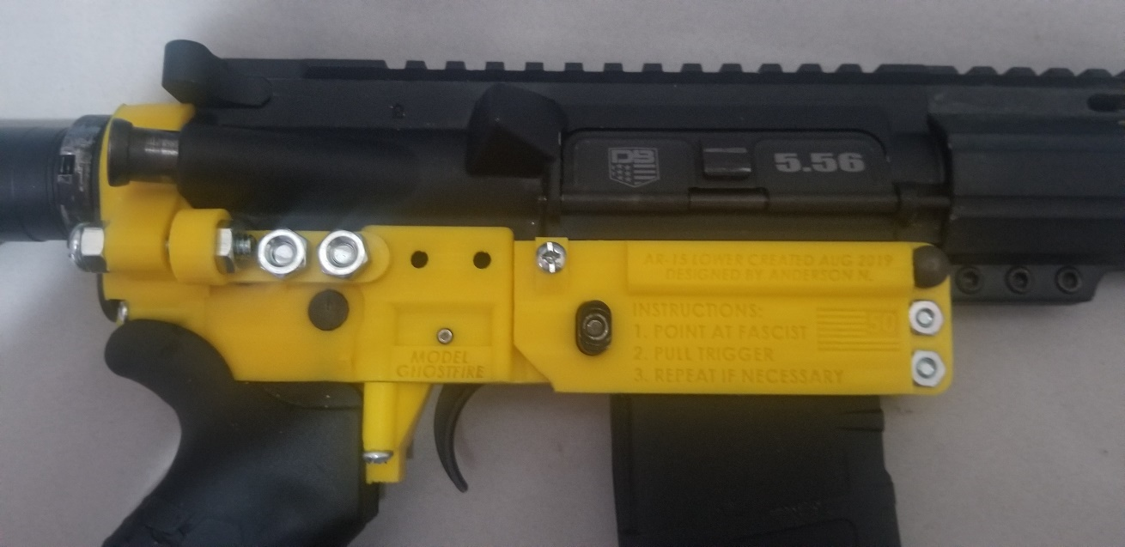

This test involved 40rnds of American Eagle 55Grain 5.56 NATO Full Metal Jacket. The test proved a breakthrough: The weapon was expected to explode around the buffer tower, but it did not. The weapon performed without major malfunction except one error caused by faulty design: The buffer didn’t press against the Bolt Carrier, and thus it always didn’t go into battery after each shot. It is only when I tap (not press intensely or jab at) the forward assist did it go into battery all the way for a successful discharge of the cartridge. That said, this was a design error on my part and had nothing to due with the firearm itself, nor did this result in any major malfunctions of the firearm. Every sequential discharge of the firearm was fully successful. In other words, the early variants of the rifle did not ever explode. Thank God.

August 31, 2019

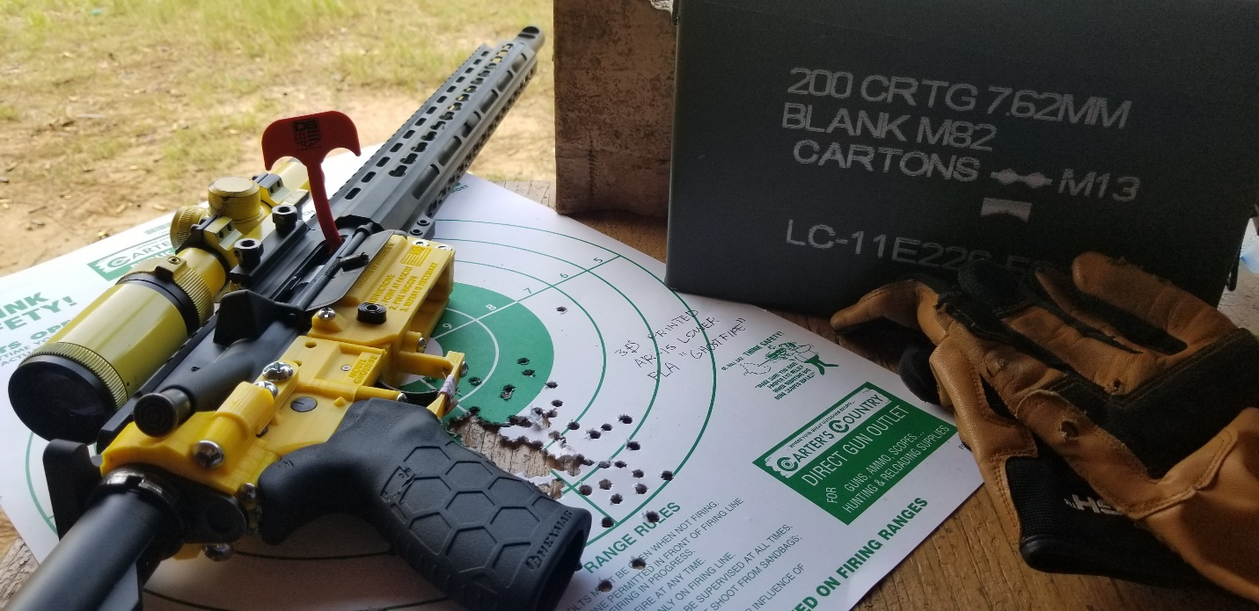

To improve the design and fix issues with the out of battery malfunctions, I consulted the advice of veteran 3D Printed gun designs of the FOSSCAD community. While they were excited, there were glaring issues that needed addressing, and major no-compromises changes I had to make. Firstly, the buffer tower had to be thicker. No debates about that. Secondly, the reinforcements had to be thicker. Again, no debate about this either. The third was simple: make the buffer tube touch the forward carrier, which would ensure that an out of battery malfunction was off the table.

A test was carried out, shooting a whopping 150rnds of 55Grain .223Rem Monarchy in a Lacquer Coating Steel Case cartridge. The only malfunction of the whole test was a double feed caused by improper loading of a magazine (User error, not design). Other than that, the weapon ate through 150 rounds without issues, and no malformations, cracks, or breaks occurred whatsoever despite the weapon heating up to the point of producing steam from the barrel. It was absolute hell, and the lower performed perfectly.

Conclusions



After extensive testing, the weapons system did not produce malfunctions, malformations, deformations, or cracks that would indicate that the weapon would explode after 150 rounds fired into it. HOWEVER, this doesn’t exonerate the weapon from the possibility of exploding or malfunctioning beyond repair after you shoot more than 150 rounds fired into it. I’m sure that anyone who isn’t a broke ass college student who can afford more than 200 rounds can make this lower explode. One thing I can say is that for a lower to surpass 90 rounds or 3 magazines of continuous fire (this one 150) makes the weapon capable of surviving a small arms engagement or skirmish. In other words, in the event of an insurgency or catastrophic meltdown of the general public, rest assured that this design will get you a functional firearm without Federal, State, or Local interference. Make sure to follow the law, if the rule of law interest you.

Materials and Tools

Tools used in the building process:

* Phillips Head Screwdriver
* Flat Head Screwdriver
* Hex Screwdriver (for the screw used in the pistol grip)
* Drill (Saves a lot of headache over the Philips and flat head. Optional but recommended)
* Pincers (Optional, used to get the hex nuts to fit into place.)
* Brass punches (Optional, used to get pins into place)
* Steel/Iron File or sandpaper to soften sharp edges for fitting
* Brass hammer (to get those pins in)

Screws and Nuts:

|  |  |  |
| --- | --- | --- |
| **Quantity** | **Material Specifications** | **Key Name** |
| 2 | #8-32 X 1-1/2 in - ROUND HEAD COMBO MACHINE SCREW | A |
| 6 | #8-32 X 1 in - ROUND HEAD COMBO MACHINE SCREW | B |
| 6 | #8-32 X ½ in - ROUND HEAD COMBO MACHINE SCREW | C |
| 4 | ¼ in-20 X ¾ in - ROUND HEAD COMBO MACHINE SCREW | D |
| 2 | ¼ in-20 X 1 in - ROUND HEAD COMBO MACHINE SCREW | E |
| 1 | #8 – FLAT WASHER | F |
| 4 | #8-32 – MACHINE SCREW NUTS | G |
| 1 Set | Pistol Grip Screw (should come with your AR Kit or Grip) | H |

While the optional tools are not needed, I find that having them makes the build process a lot easier and less stressful. Since everything is in PLA, the plastic itself doesn’t have threads printed into each hole since that will require a super fine layer height in the 3D printer, thus each hole you insert a screw into will have to be “forced” in. This is where having a drill can save the day. I made sure to only use screws with imperial specifications, meaning they can be easily found in any Lowes and Home Depot. To make matters easier, there are machine screw kits with all the necessary screws and nuts within. Make sure to read the packaging of the kits to make sure they have all the screws inside.

Assembly is much like an IKEA furniture. In the Screws and Nuts graph above, each part has a key name attached from A to H. This will help you assemble the parts easier and know which screw/nut goes where. The steps need to be followed chronologically to ensure a successful build.

Manufacturing

Very obviously you will need a 3D Printer capable of PLA or ABS. Make sure that you have enough filament to print with, about 150grams of PLA for a complete lower and assuming the print goes well. The bed needs to be able to fit a 12x12x5 dimensions (xyz, centimeters respectively). If your bed is only a 10x10, simply rotate the parts diagonally on the print bed to fit the pieces. NO SUPPORTS OR ADHESION is needed on any of your parts. Always shoot for 100% infill. Any other specifics will be specified in the next step.

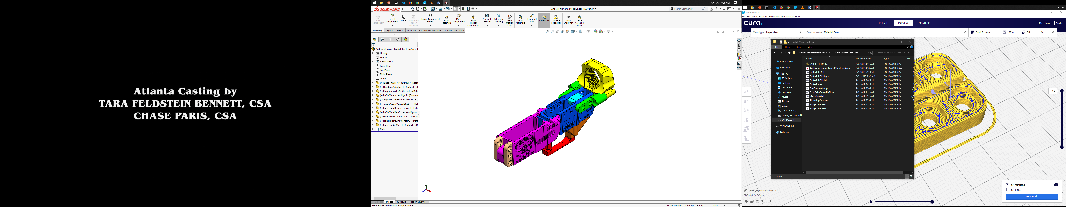

|  |  |
| --- | --- |
| **Color** | **Part Name** |
| Dark Blue | Fire Control Group |
| Purple | Magazine Well |
| Red | Trigger Guard |
| Yellow | Buffer Tower |
| Brown | Pistol Grip Adapter |
| Green | Buffer To FCG Struts |
| Tan | Forward Take Down Pin Shaft |
| Light Blue | Buffer to FCG Center |

The Graph above corresponds to the picture with colored components. Study it and commit to memory. In a standard AR Parts kit or a FCG/Trigger Assembly you will find the following:

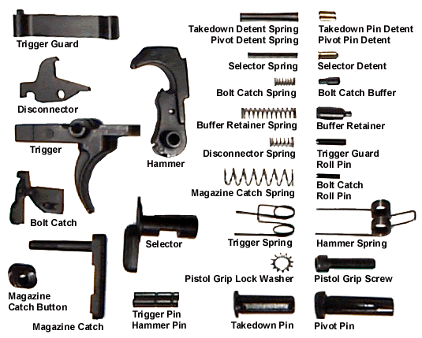

In the next step, start printing the parts one by one. The following graphs and pictures are important to making sure the parts are printed with the correct settings, as some parts require specific settings and orientations essential to making the lower survive as many rounds as it did during testing.

|  |  |  |  |
| --- | --- | --- | --- |
| **.stl file name** | **Quantity** | **Layer Height** | **Wall Line Count** |
| BufferToFCG_Left | 1 | .1 | 4 |
| BufferToFCG_Right | 1 | .1 | 4 |
| BufferToFCG_Mid | 1 | .2 | 4 |
| BufferTower | 1 | .2 | 6 |
| FireControlGroup | 1 | .1 | 4 |
| FrontTakeDownPinShaft | 2 | .1 | 6 |
| MagazineWell | 1 | .1 | 4 |
| PistolGripAdapter | 1 | .1 | 6 |
| TriggerGuardPt1 | 1 | .2 | 4 |
| TriggerGuardPt2 | 1 | .2 | 4 |

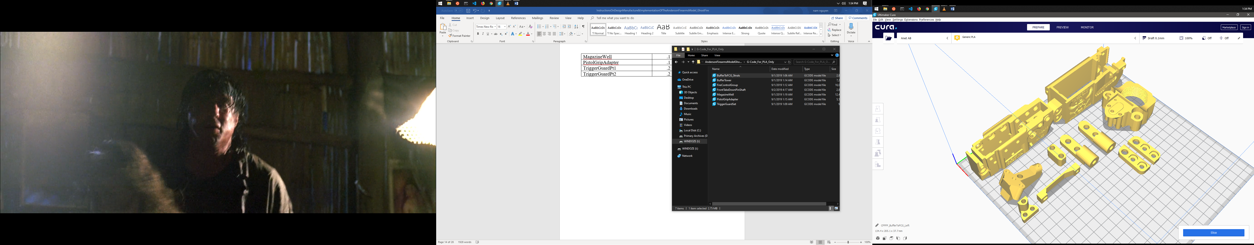

Refer to the picture and the graph accordingly. The parts are not to be printed all at once as shown, the picture is only here to show the correct orientation of each part. The Buffer Tower, Magazine Well and Fire Control Group need to be printed alone for the best performance. NOTE that the FrontTakeDownPinShaft needs to be printed twice.

Assembly

The assembly is designed to work like adult Legos. Excess force should never be needed to assemble the pieces together. If they don’t fit when they should, use a file or sandpaper to smooth out the edges, and try to fit them again. Refer to <https://www.mcarbo.com/AR-15-Lower-Reciver-Build.pdf> to learn how to assemble the lower. This assembly will help you build the lower as you add parts.

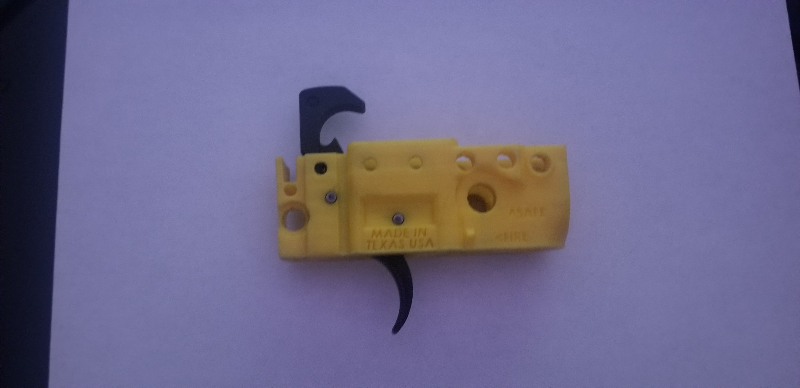

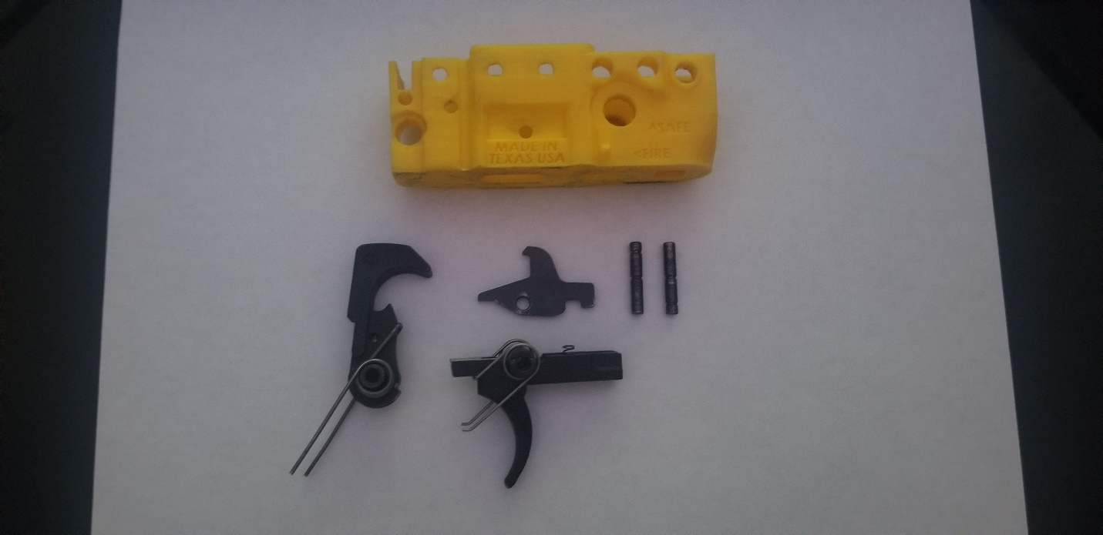Start off by putting the trigger and hammer together, and into the Fire Control Group. Refer to the pdf linked above to see how the assembly is supposed to look like. You can cock the hammer and test fire using the trigger to see if it works right. REMEMBER that when dry firing here, to brace the hammer from slamming all the way because it WILL damage the fire control group if not braced.

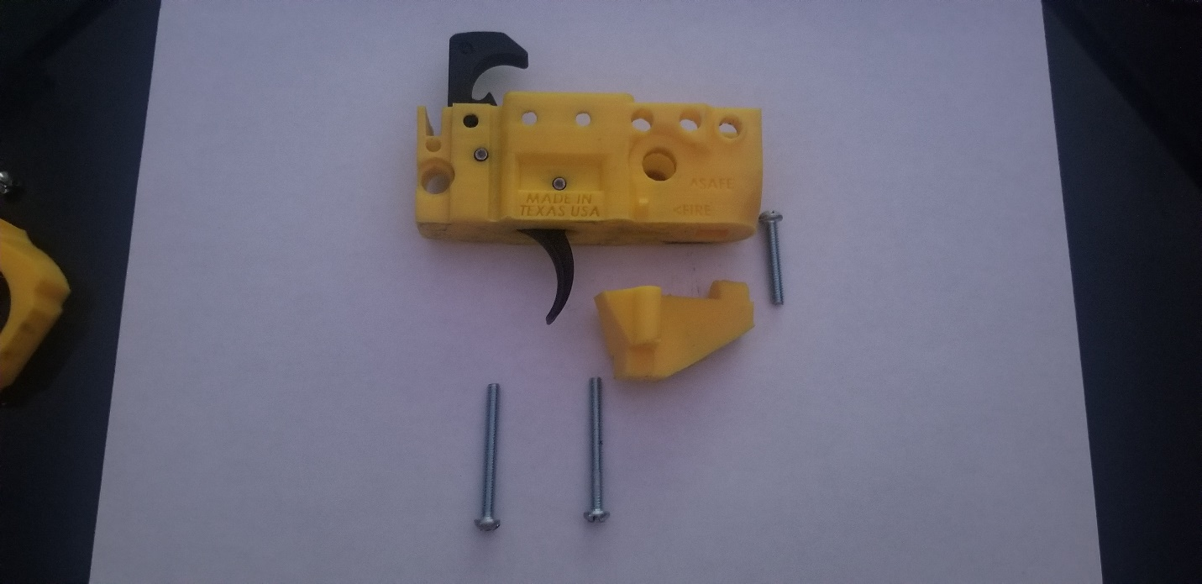

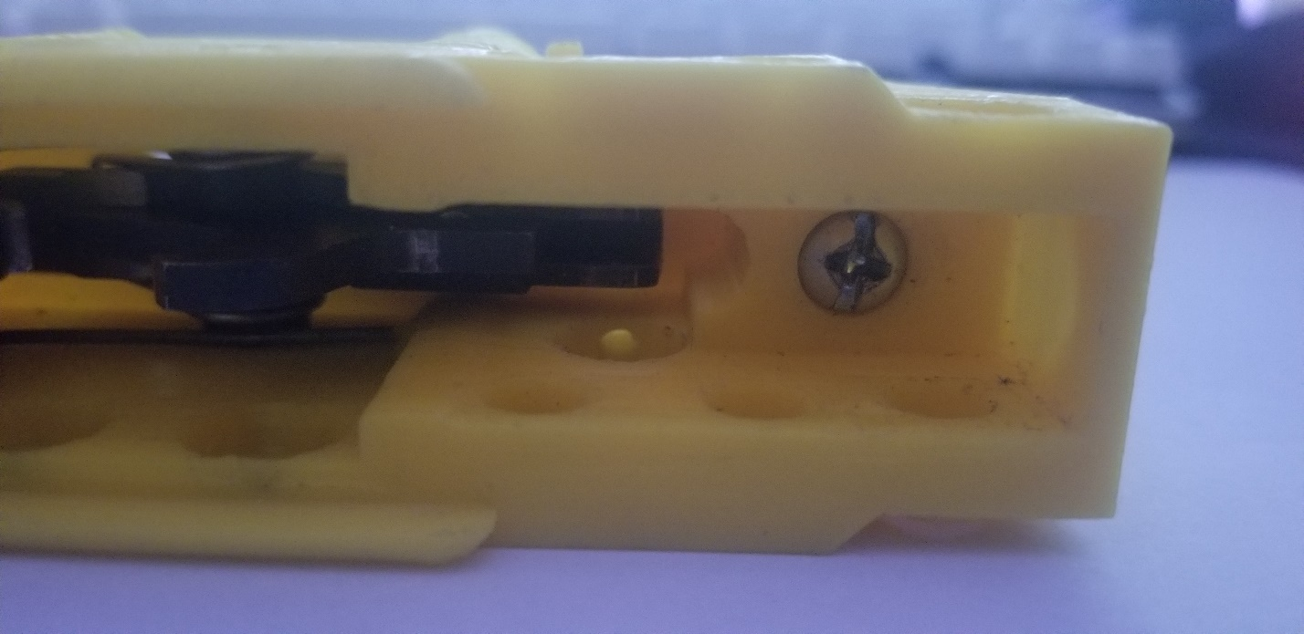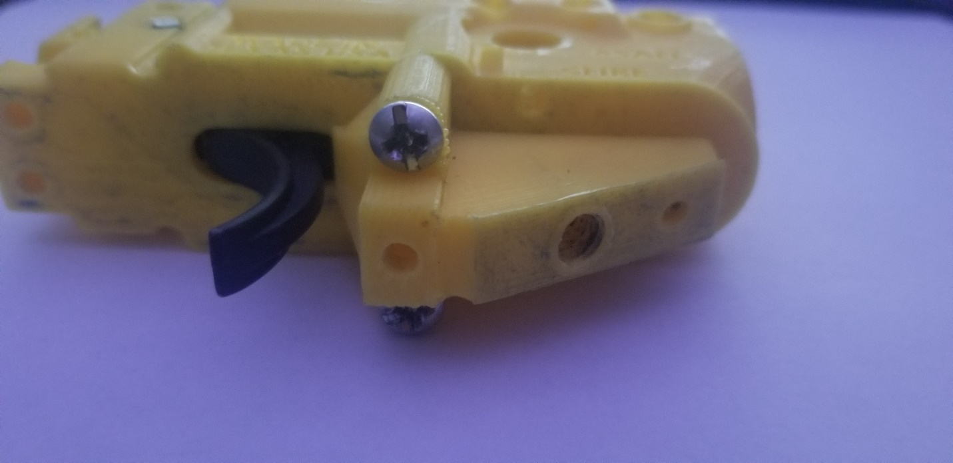

B

A

A

B

B

A

A

Add the Pistol Grip Adapter onto the Fire Control Group. Make sure to fasten the proper screws and use the images as references. Remember that the letters refer to the screw type used. The graph has been added below in case you forgot. The third shorter screw fastens from the fire control group inwards.

|  |  |  |
| --- | --- | --- |
| **Quantity** | **Material Specifications** | **Key Name** |
| 2 | #8-32 X 1-1/2 in - ROUND HEAD COMBO MACHINE SCREW | A |
| 6 | #8-32 X 1 in - ROUND HEAD COMBO MACHINE SCREW | B |
| 6 | #8-32 X ½ in - ROUND HEAD COMBO MACHINE SCREW | C |
| 4 | ¼ in-20 X ¾ in - ROUND HEAD COMBO MACHINE SCREW | D |
| 2 | ¼ in-20 X 1 in - ROUND HEAD COMBO MACHINE SCREW | E |
| 1 | #8 – FLAT WASHER | F |
| 4 | #8-32 – MACHINE SCREW NUTS | G |
| 1 Set | Pistol Grip Screw (should come with your AR Kit or Grip) | H |

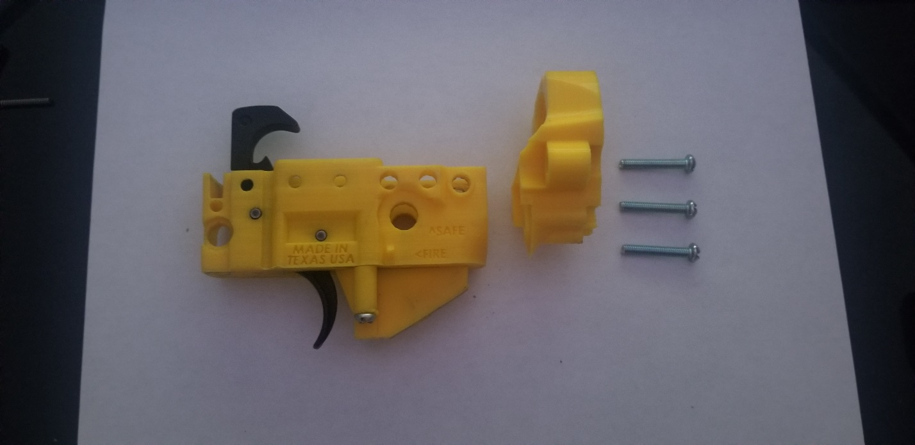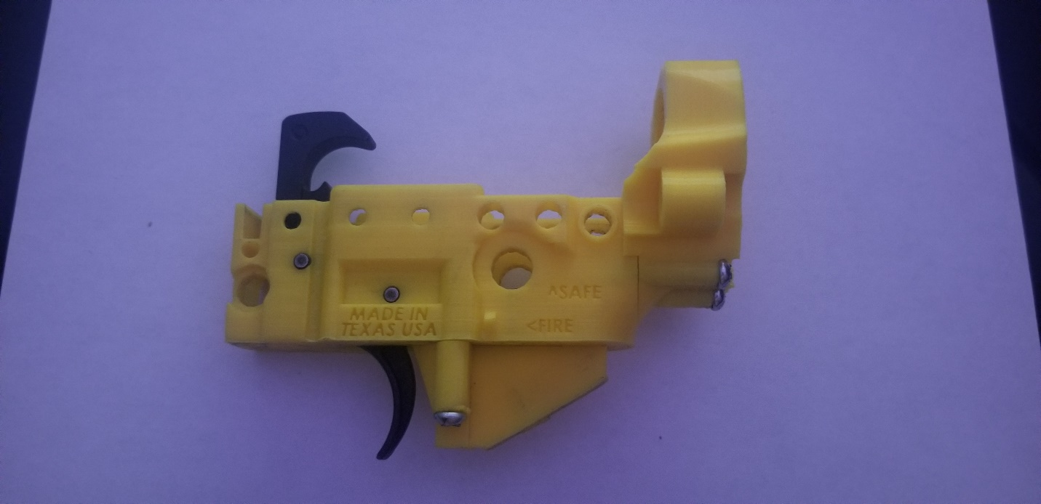 Next is to add the Buffer Tower, which uses 3 “B” screws, and fastens the buffer tube to the fire control group.

B

B

B

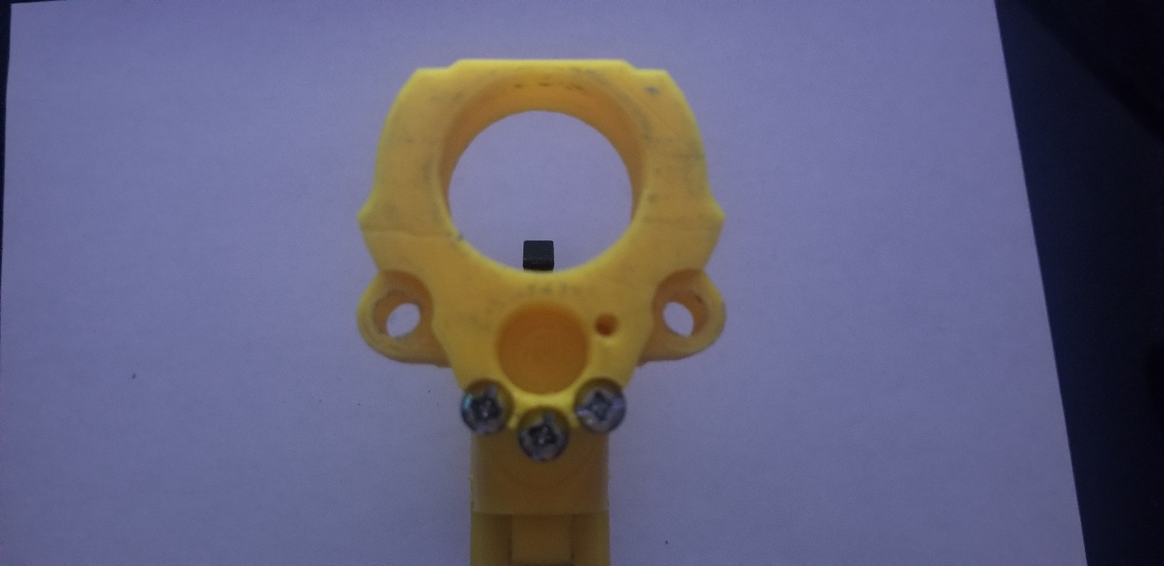

B

B

B

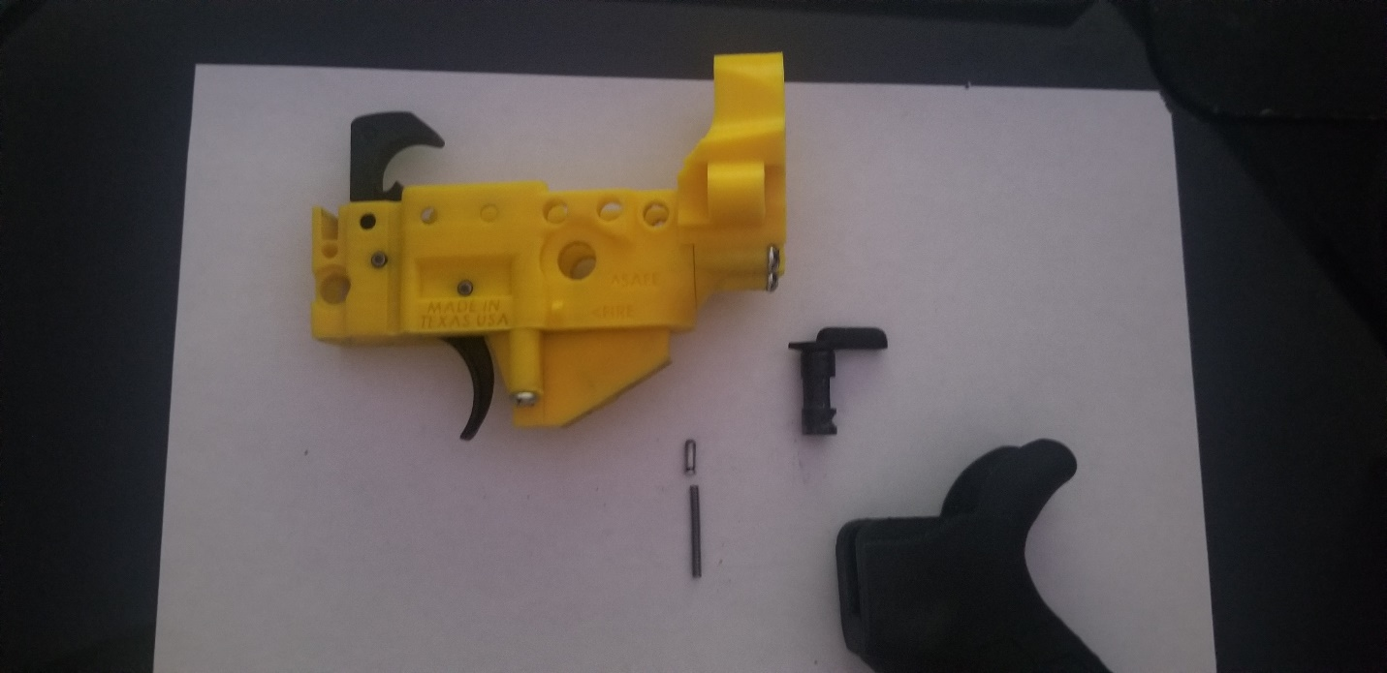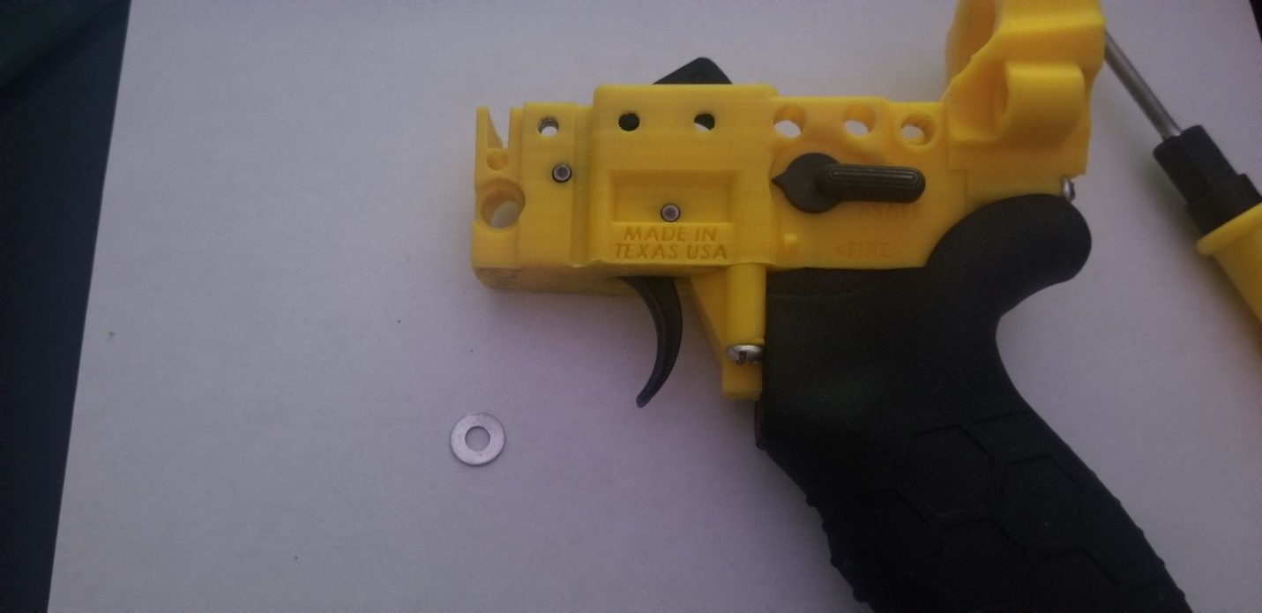 In this step, the grip and the fire selector are added. Observe how the grip sits against the buffer tower. It is important to install the buffer tower before the pistol grip. Fasten the Pistol Grip using the pistol grip screw.

H

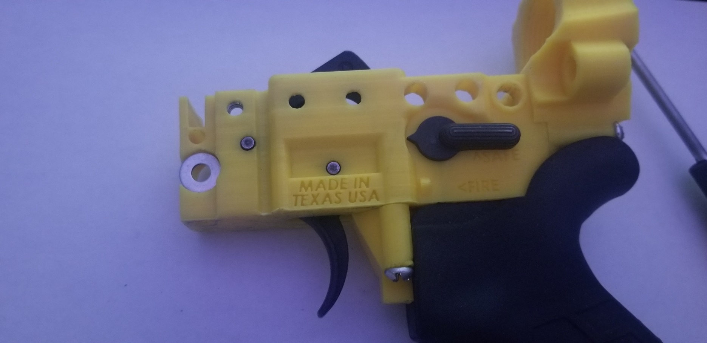 This step is important: add the washer indicated. This washer allows the magazine release spring to be installed correctly.

F

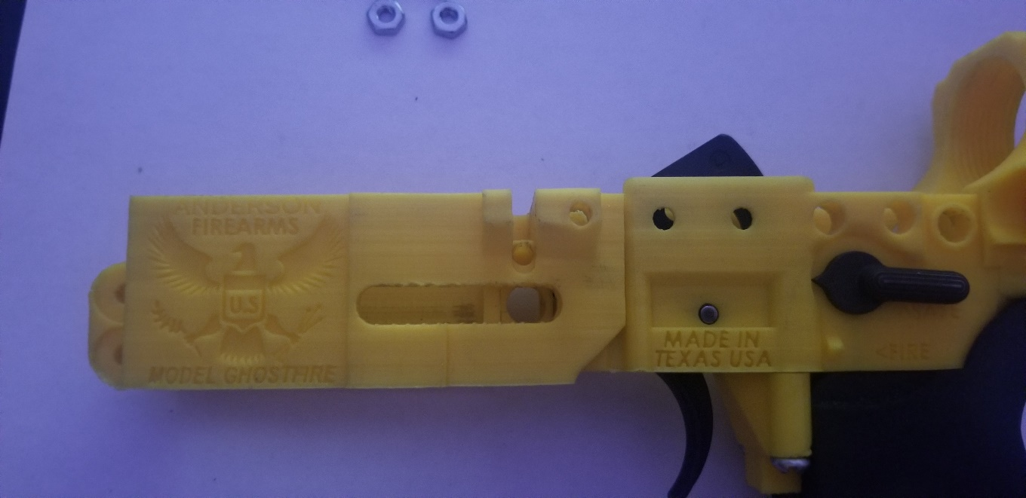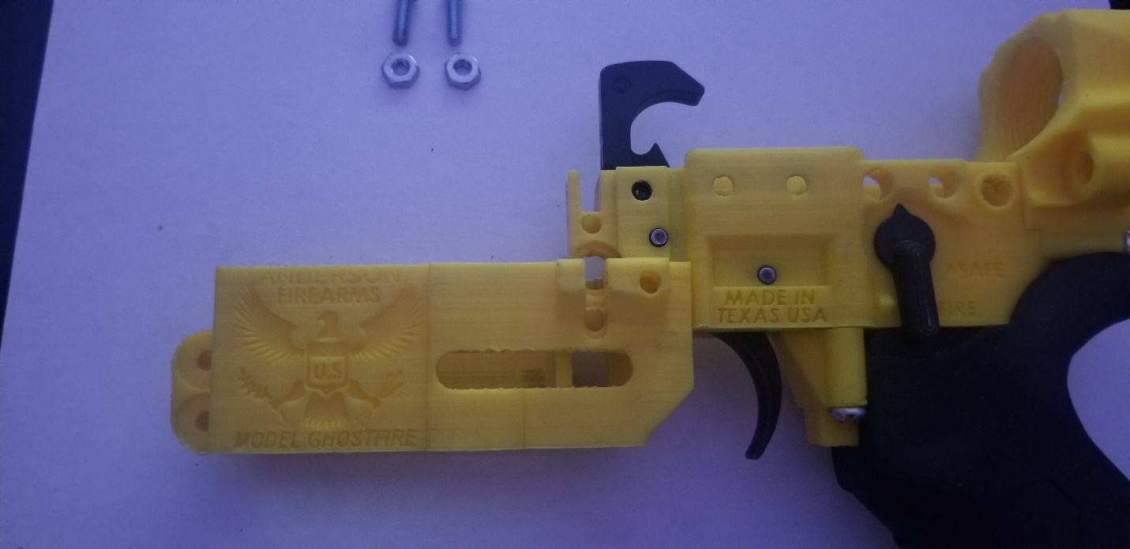

Start adding the Magazine Well to the Fire Control Group By sliding the Fire Control Group vertically into the Magazine Well. Little force may be required to fully connect the two main pieces and an audible snap may be hear once fully attached, which should not be mistaken as cracks or damages. Although the picture does not show the washer from the previous step, it should still be on the Fire Control Group when attaching the Magazine Well.

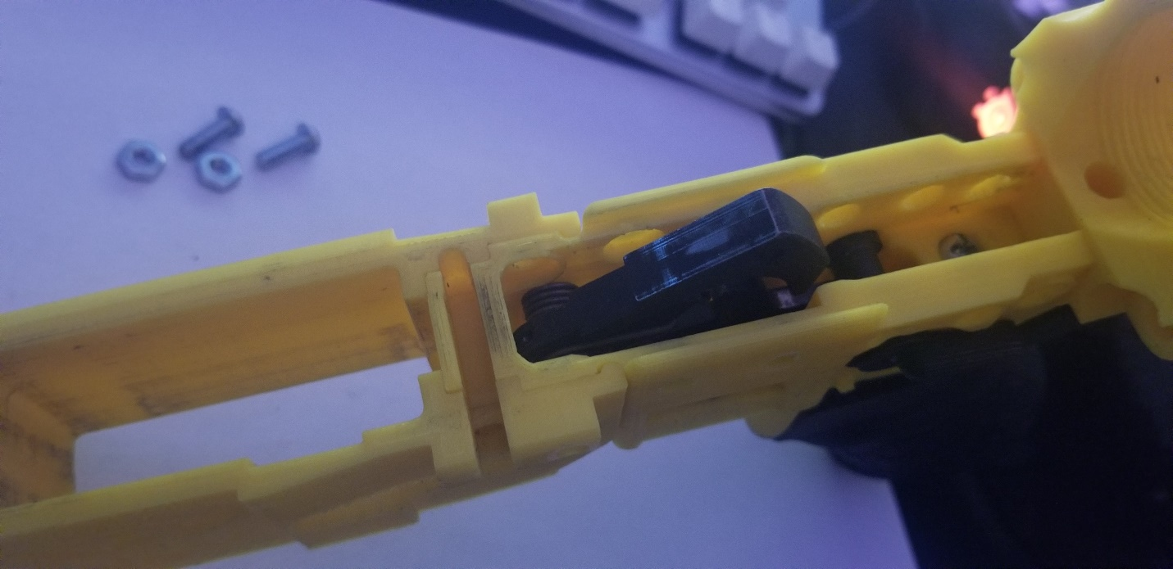 In this section you should see cut outs that would fit a hex nut. Add the hex nut, and fasten using the short screws.

C

C

G

G

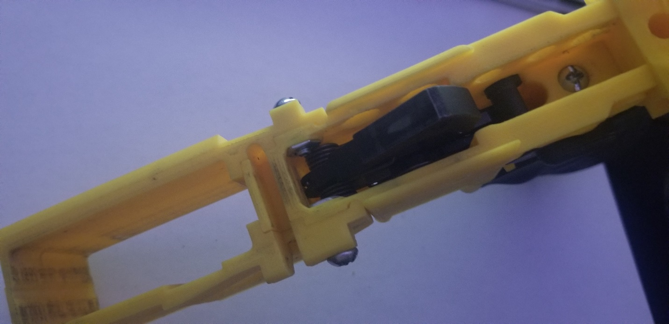 This is what it should look like when the screw and nut are added. Make certain that the hammer does not touch or contact the screw and nut when cocked and dry fired. Remember to brace the hammer when the trigger is pulled.

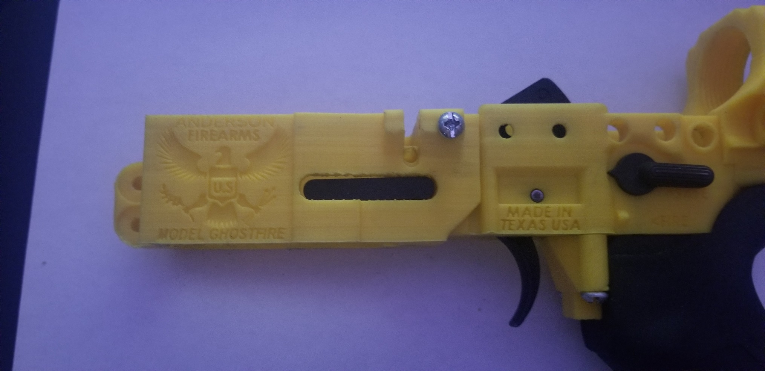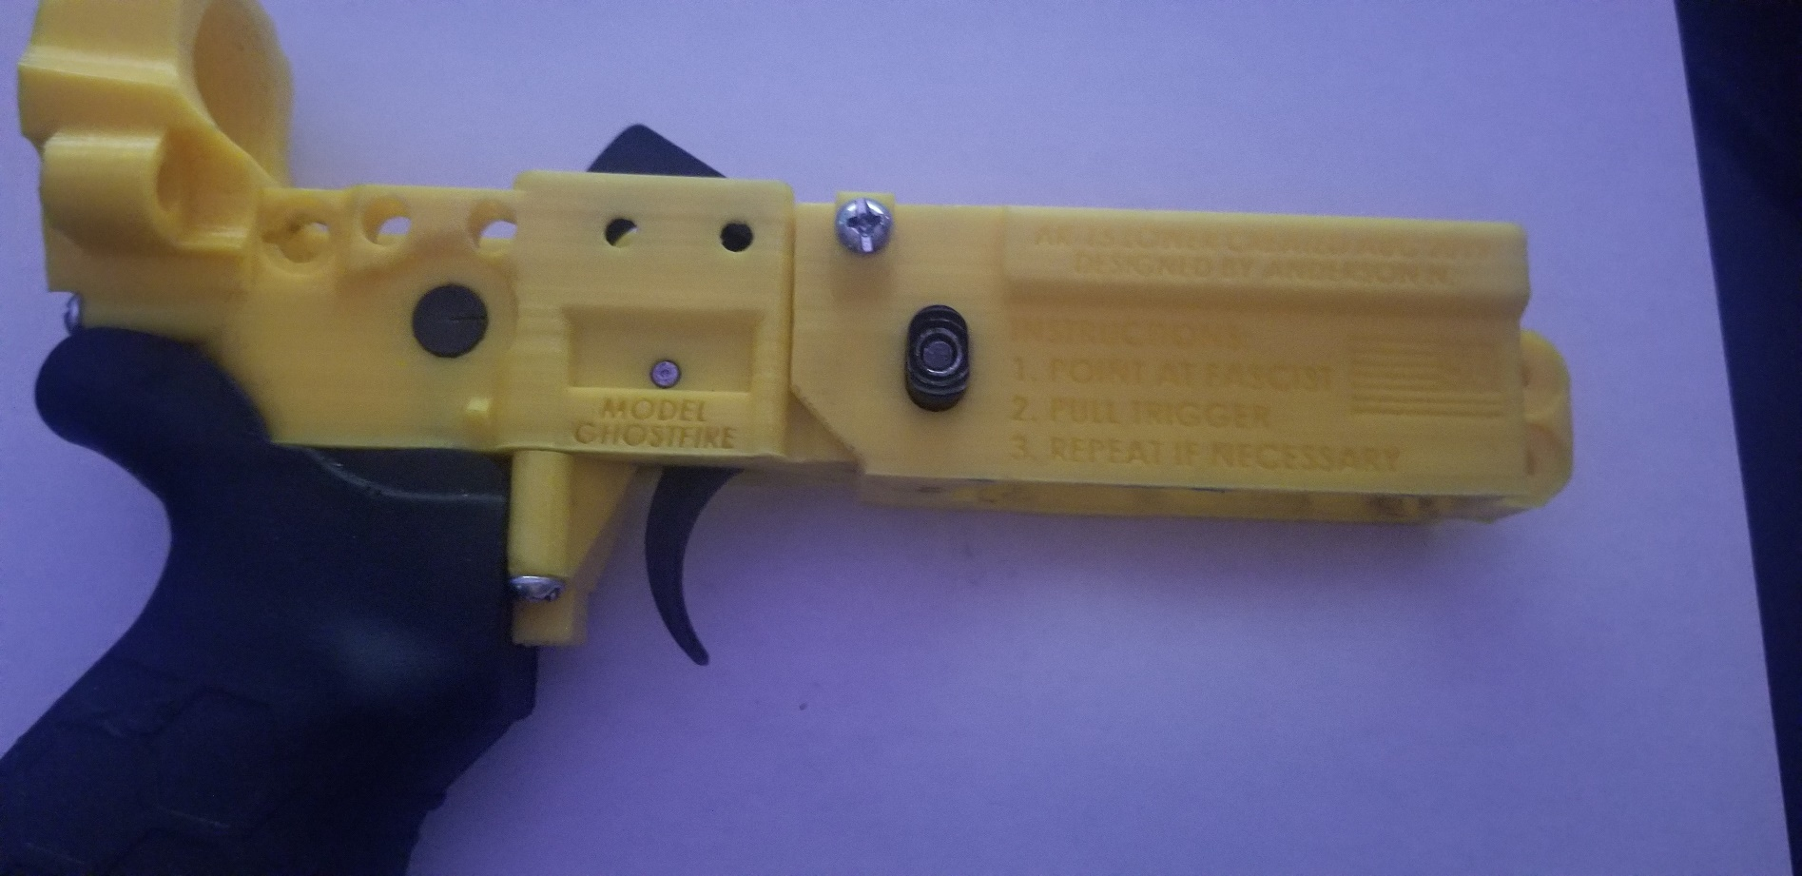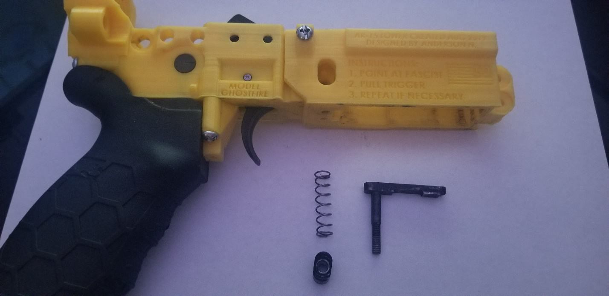

Now it’s time to add the magazine release. Once added, use an empty magazine to test the mag release. If the release gets stuck, use both thumbs and force the mag release down. Repeat the process to “Soften” the release.

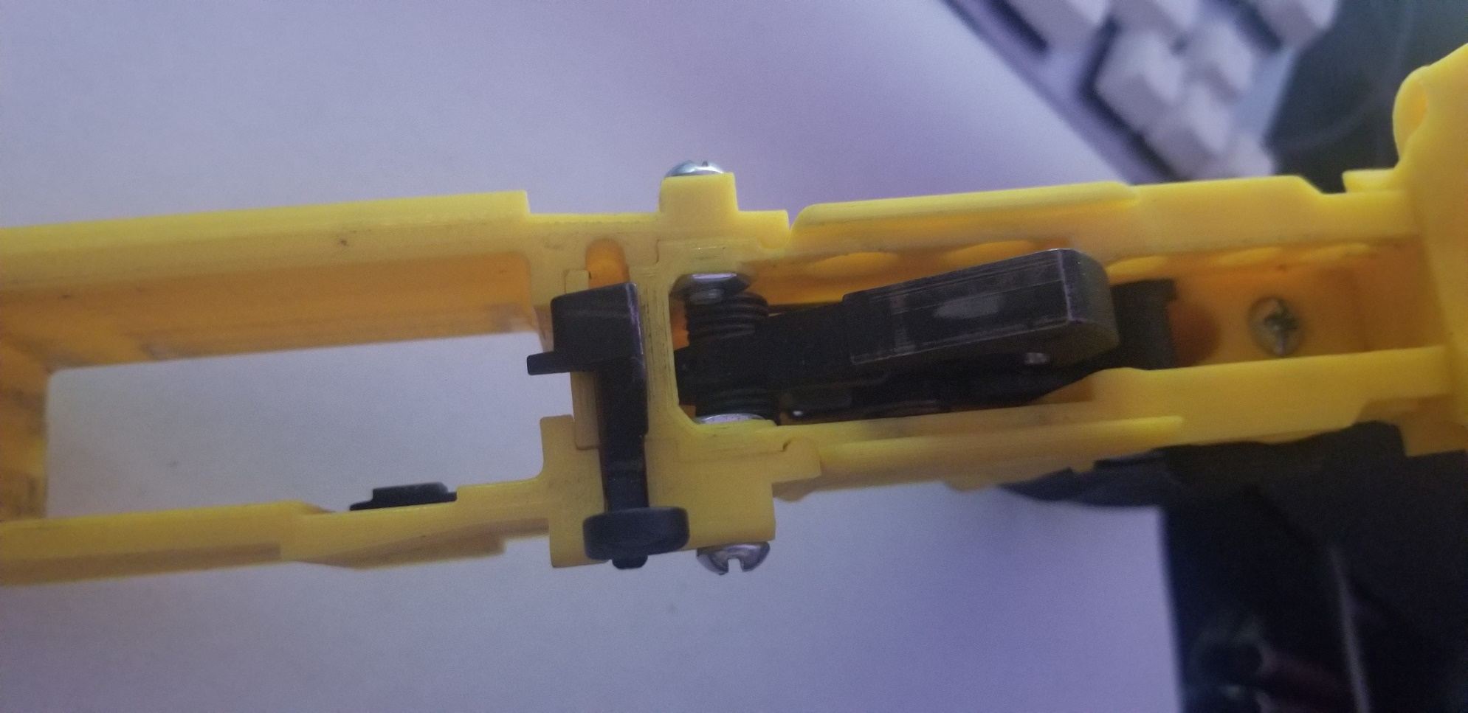

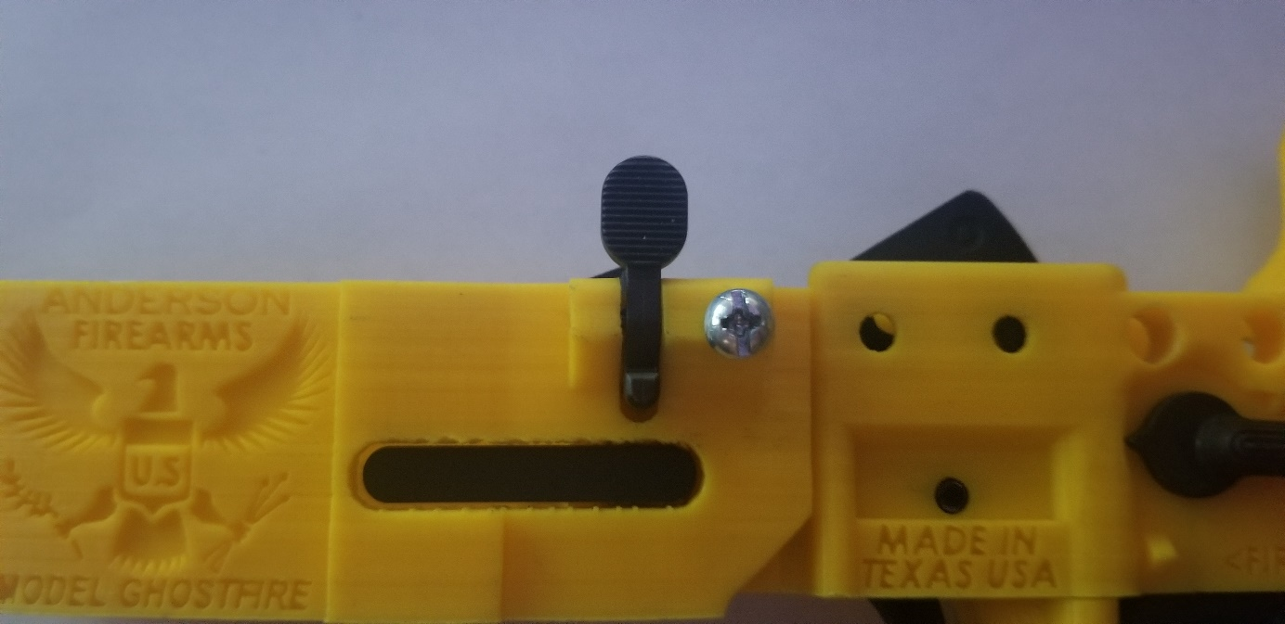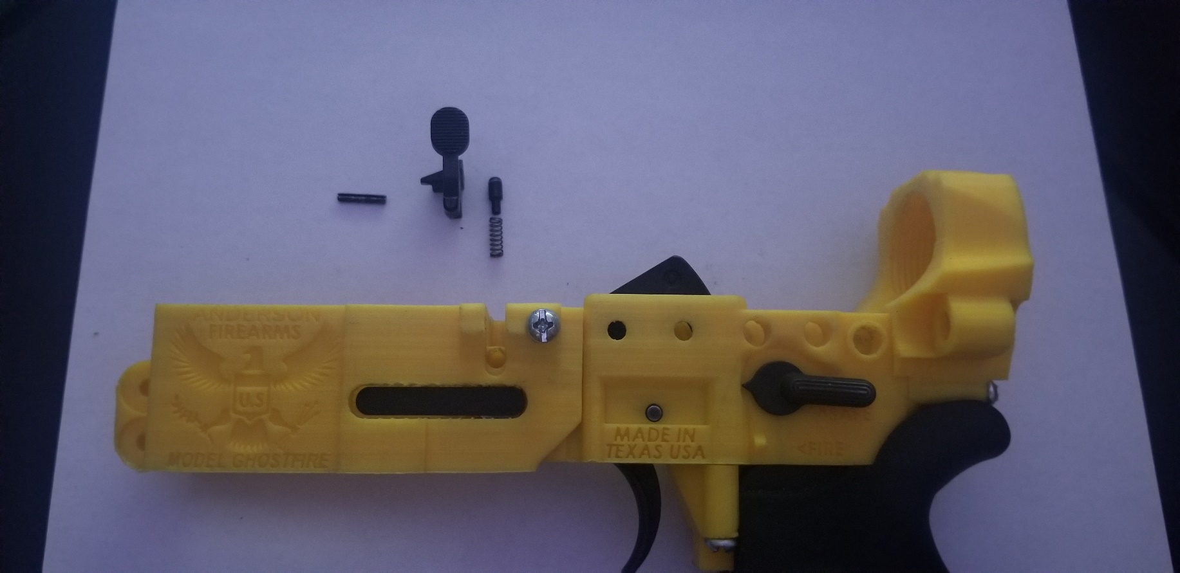

Add the Bolt Catch. Once installed, insert a magazine to test if the bolt catch touches on the magazine release.

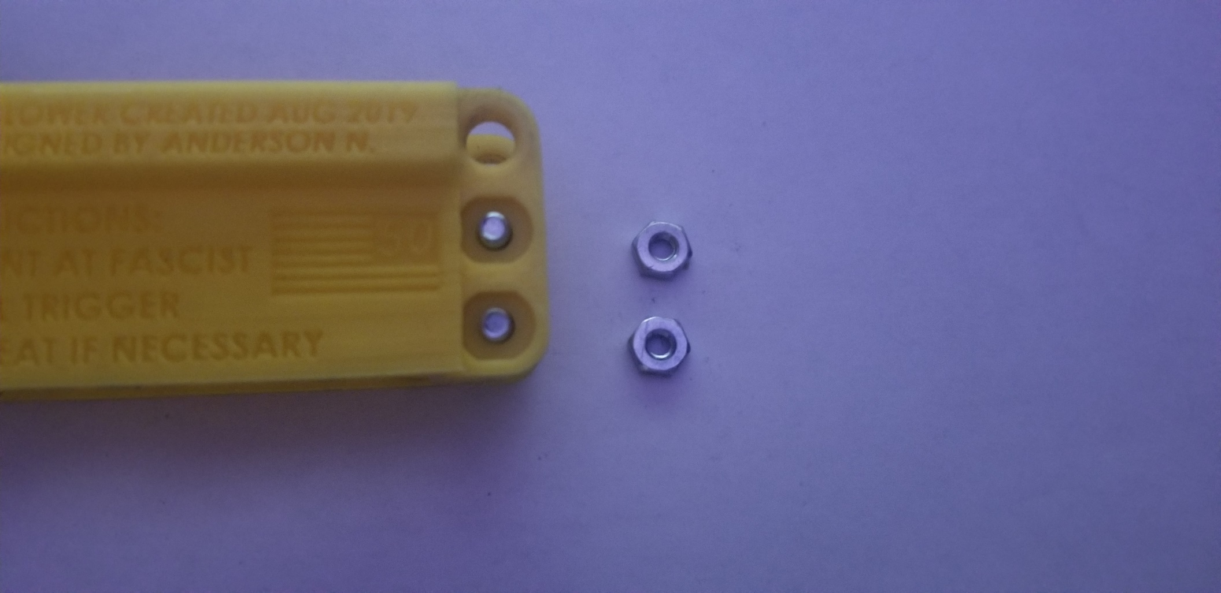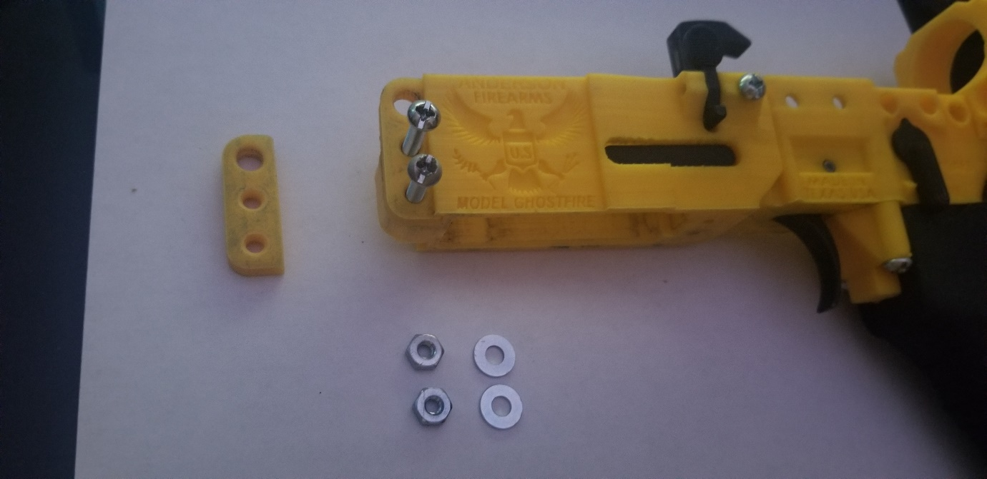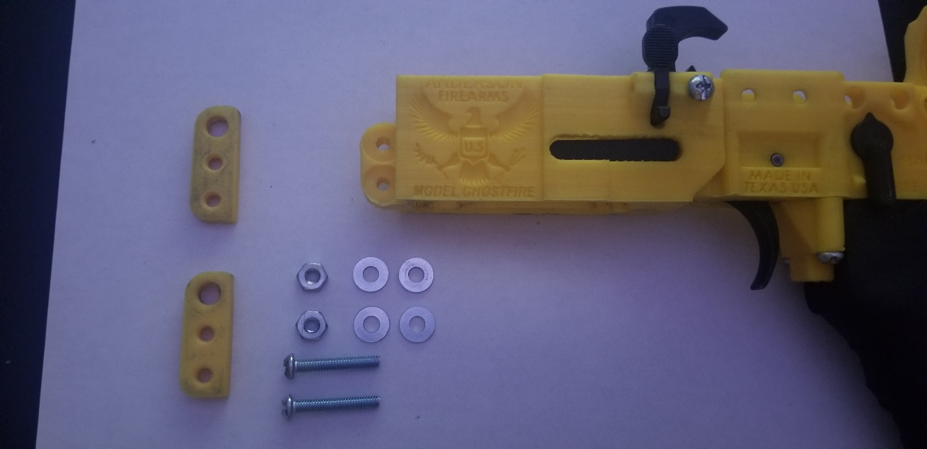

F

F

B

B

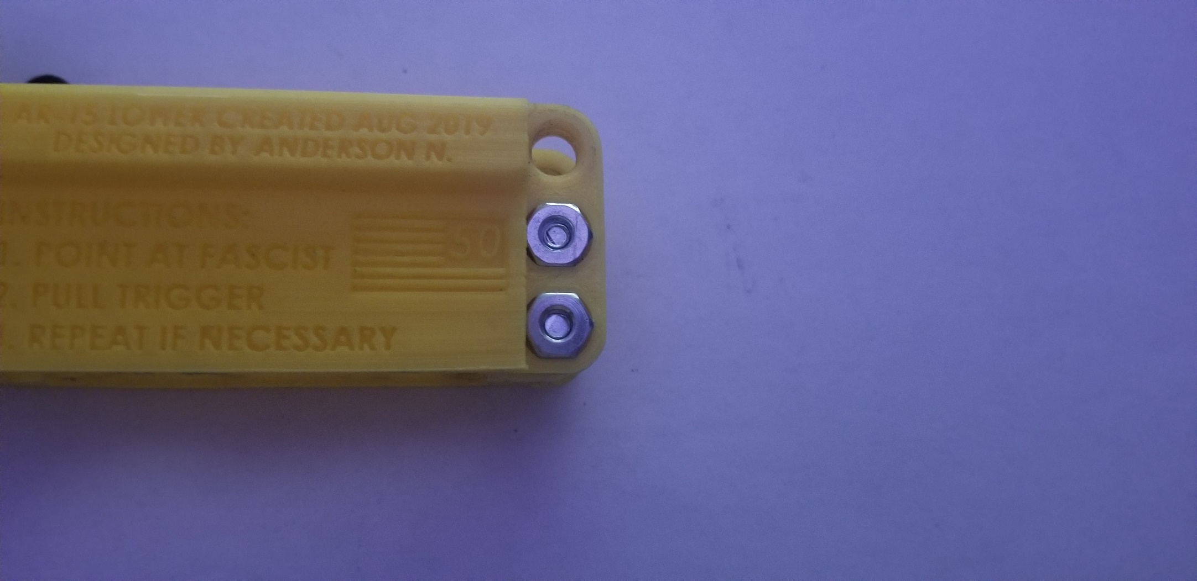

Using two short screws, four washers, and two nuts, fasten the forward takedown pin shaft.

G

G

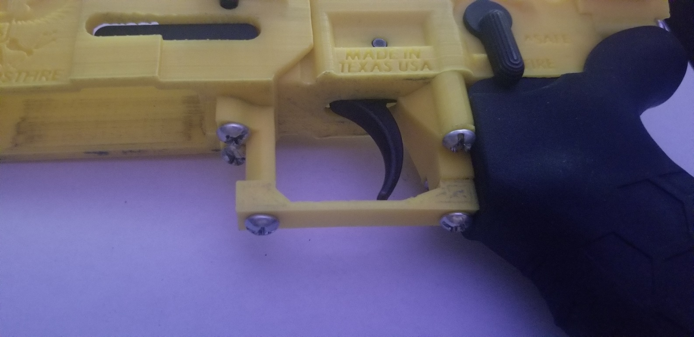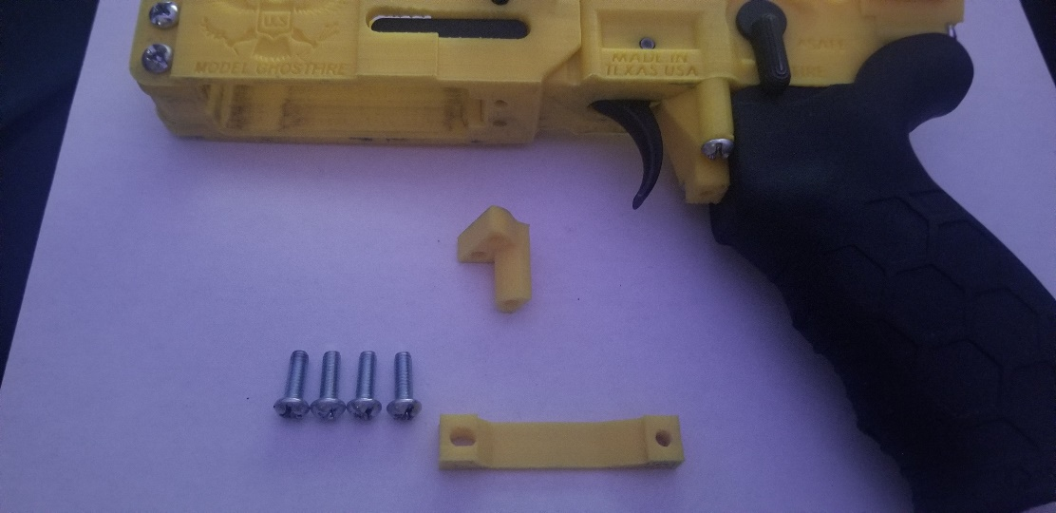

C

C

C

C

This step involves all small screws. Assemble the trigger guard using the picture as references.

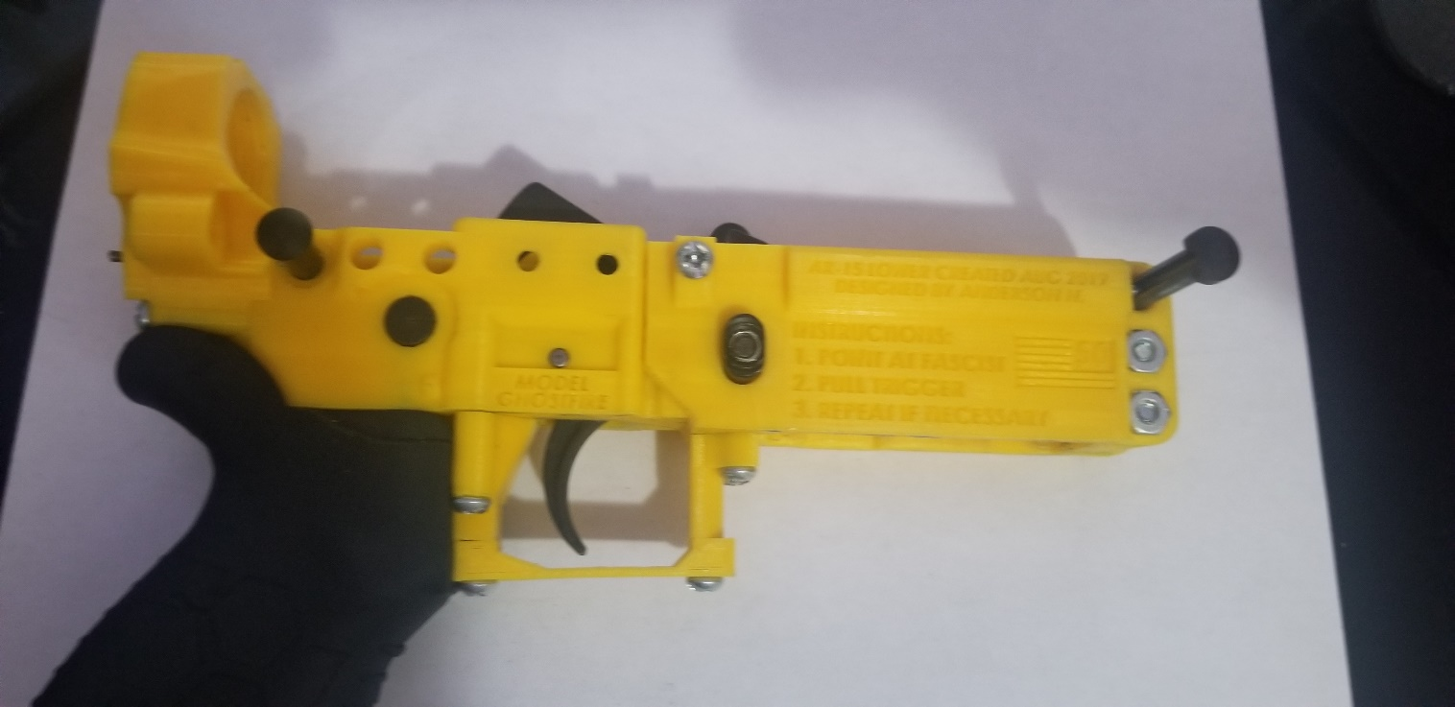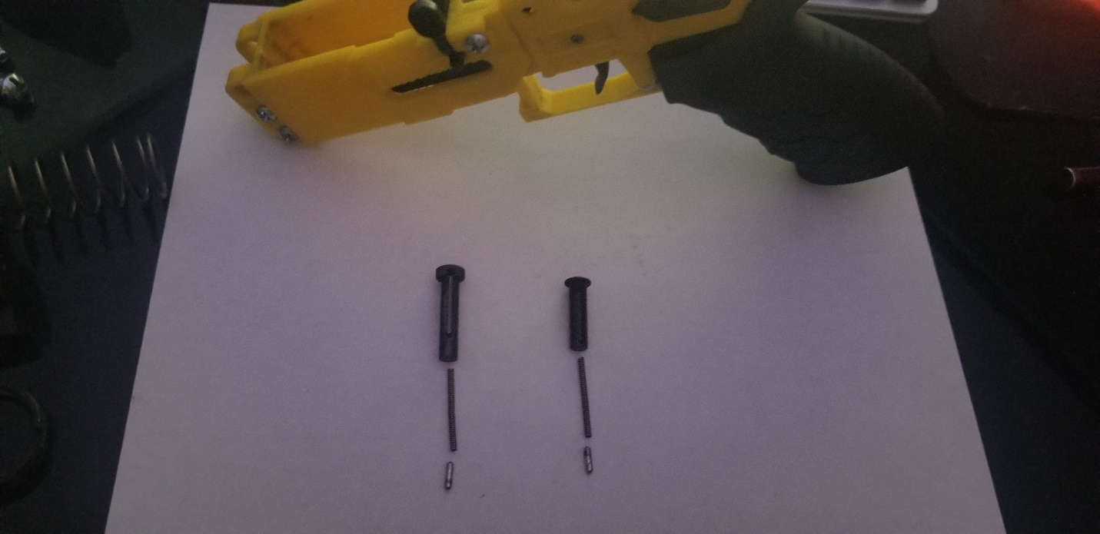

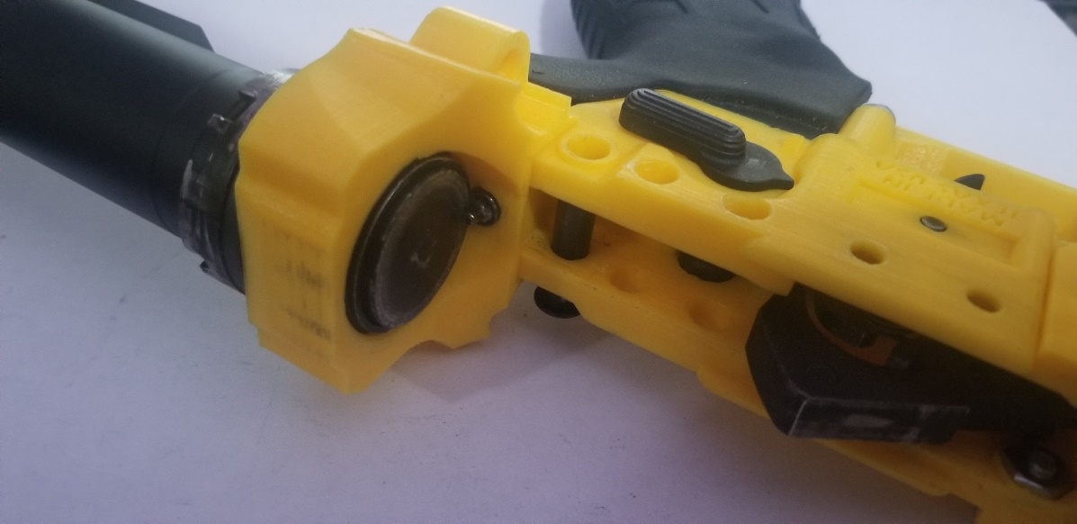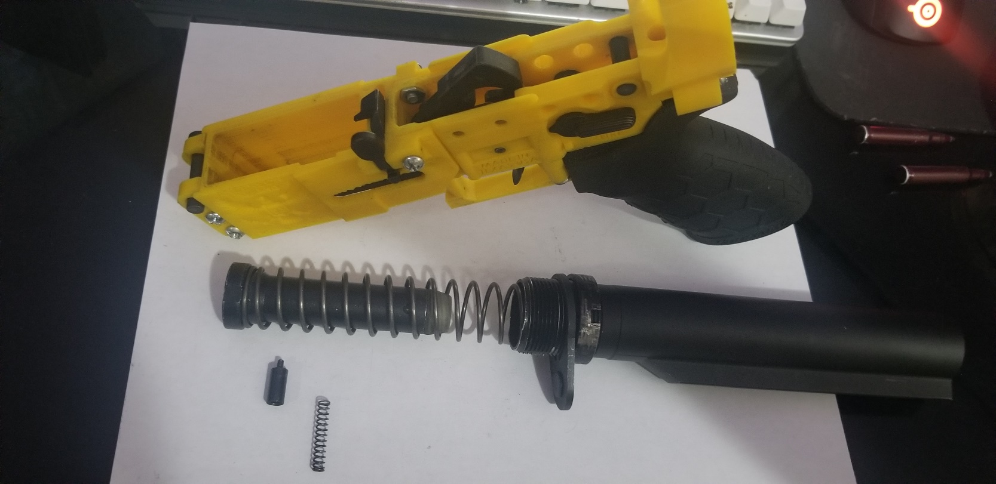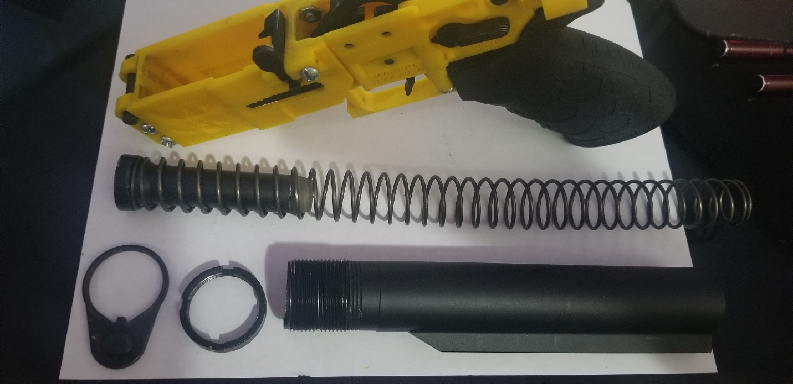Now for the hard part: Install the takedown pin themselves. Just read the pdf I linked before, as it will show how to install the takedown pins without risk of losing the pins. If you are too concerned, brace the lower against a white towel, incase the pin shoots out during installation.

Now install the buffer tube and tighten the castle nut. In this step it is ok to tighten the castle nut with force, as you would normally do with a normal lower. Tighten it to where the castle nut will not come loose when firing.

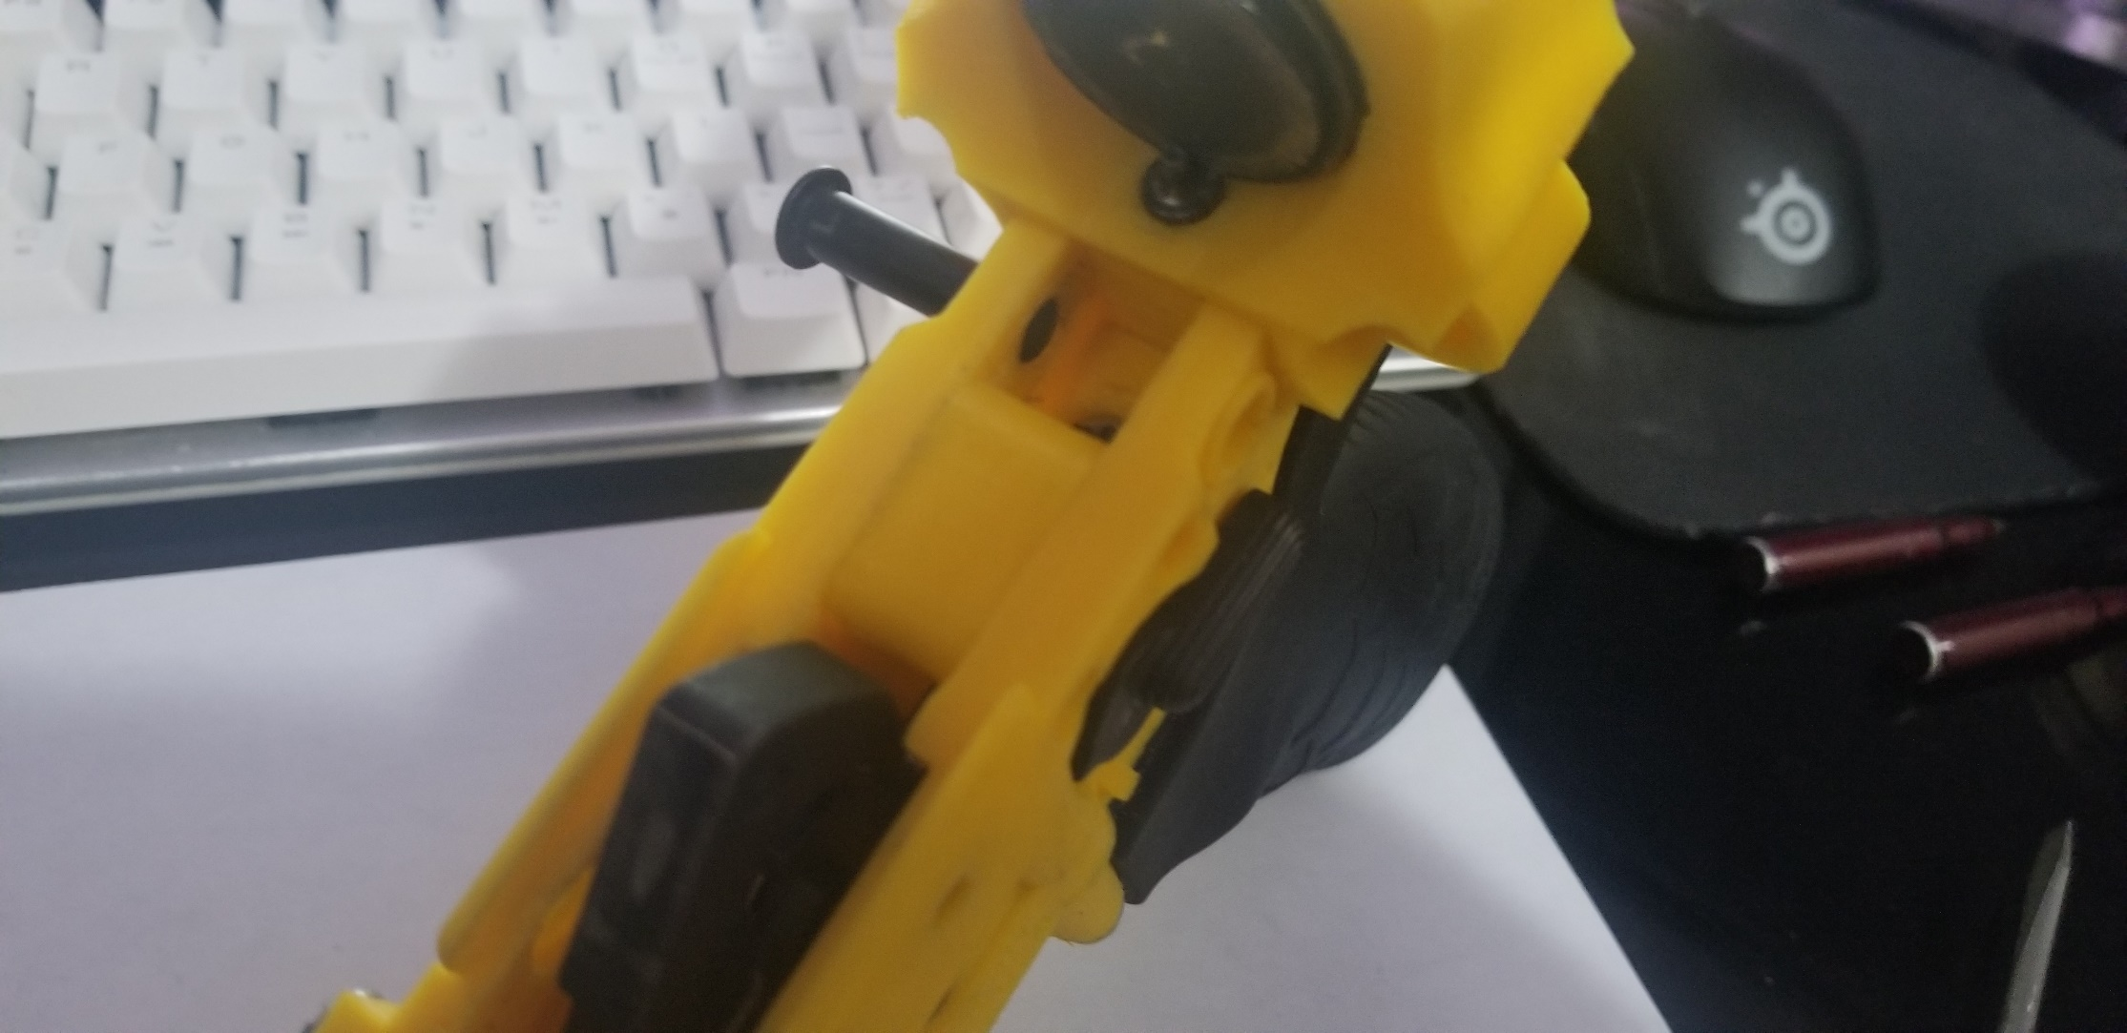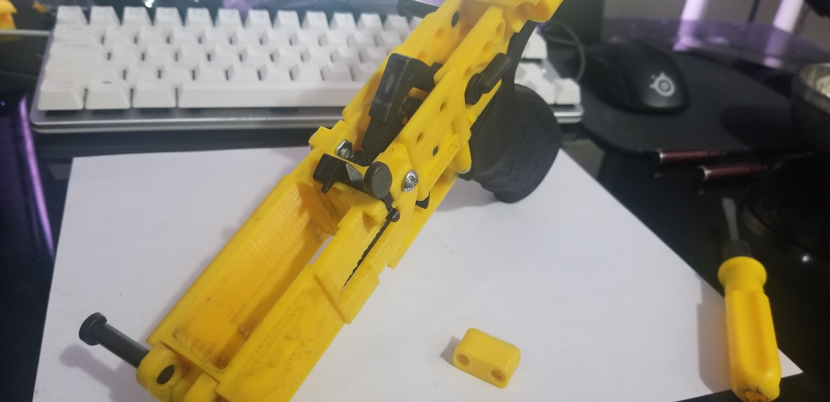

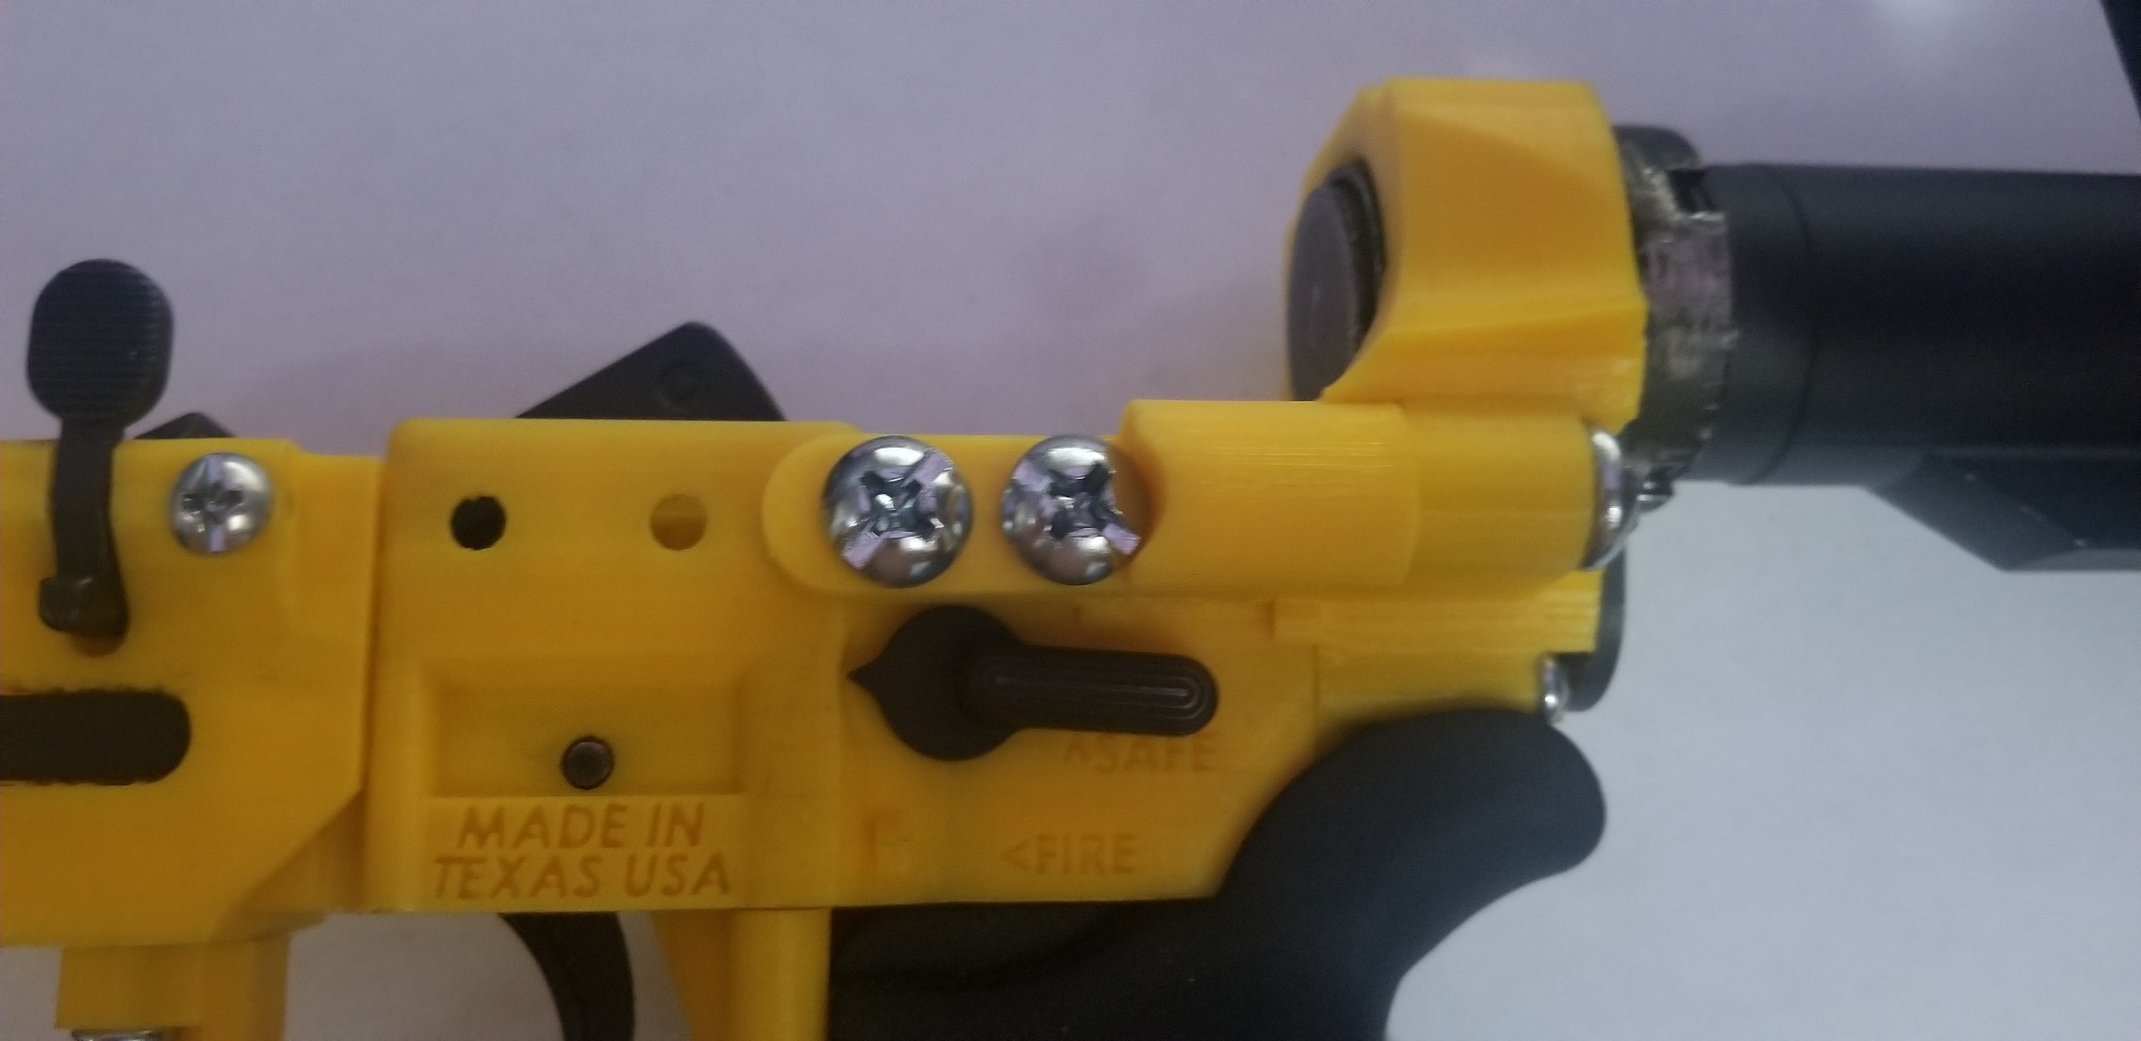Press the Buffer to FCG Mid piece into the Fire Control Group. The holes on the mid piece should be coincident to the holes on the Fire Control Group when installed.

D

E

D

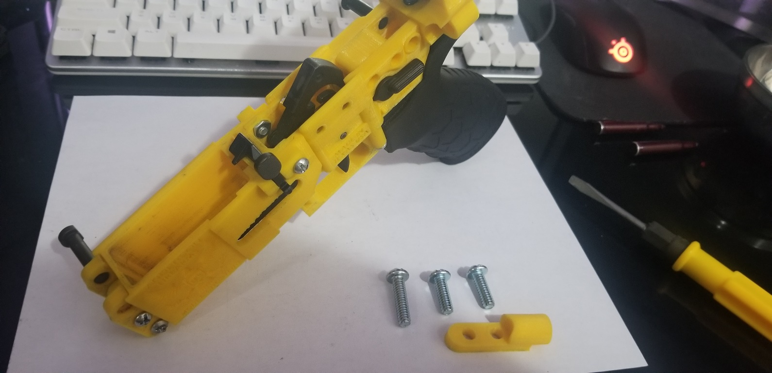 Before starting this step, it is very important that you extend both take down pins. Then install the Buffer to FCG Left piece using the appropriate screws to fasten the reinforcement piece. The screws should be tight to fasten, as designed, so use some force to tighten them in. Once fastened, attach the entire AR Upper Receiver and close the takedown pins. The pins may have difficulty closing due to tight fitting. Apply some force to close the pins. Use a brass hammer if necessary to tap the take down pins in place.

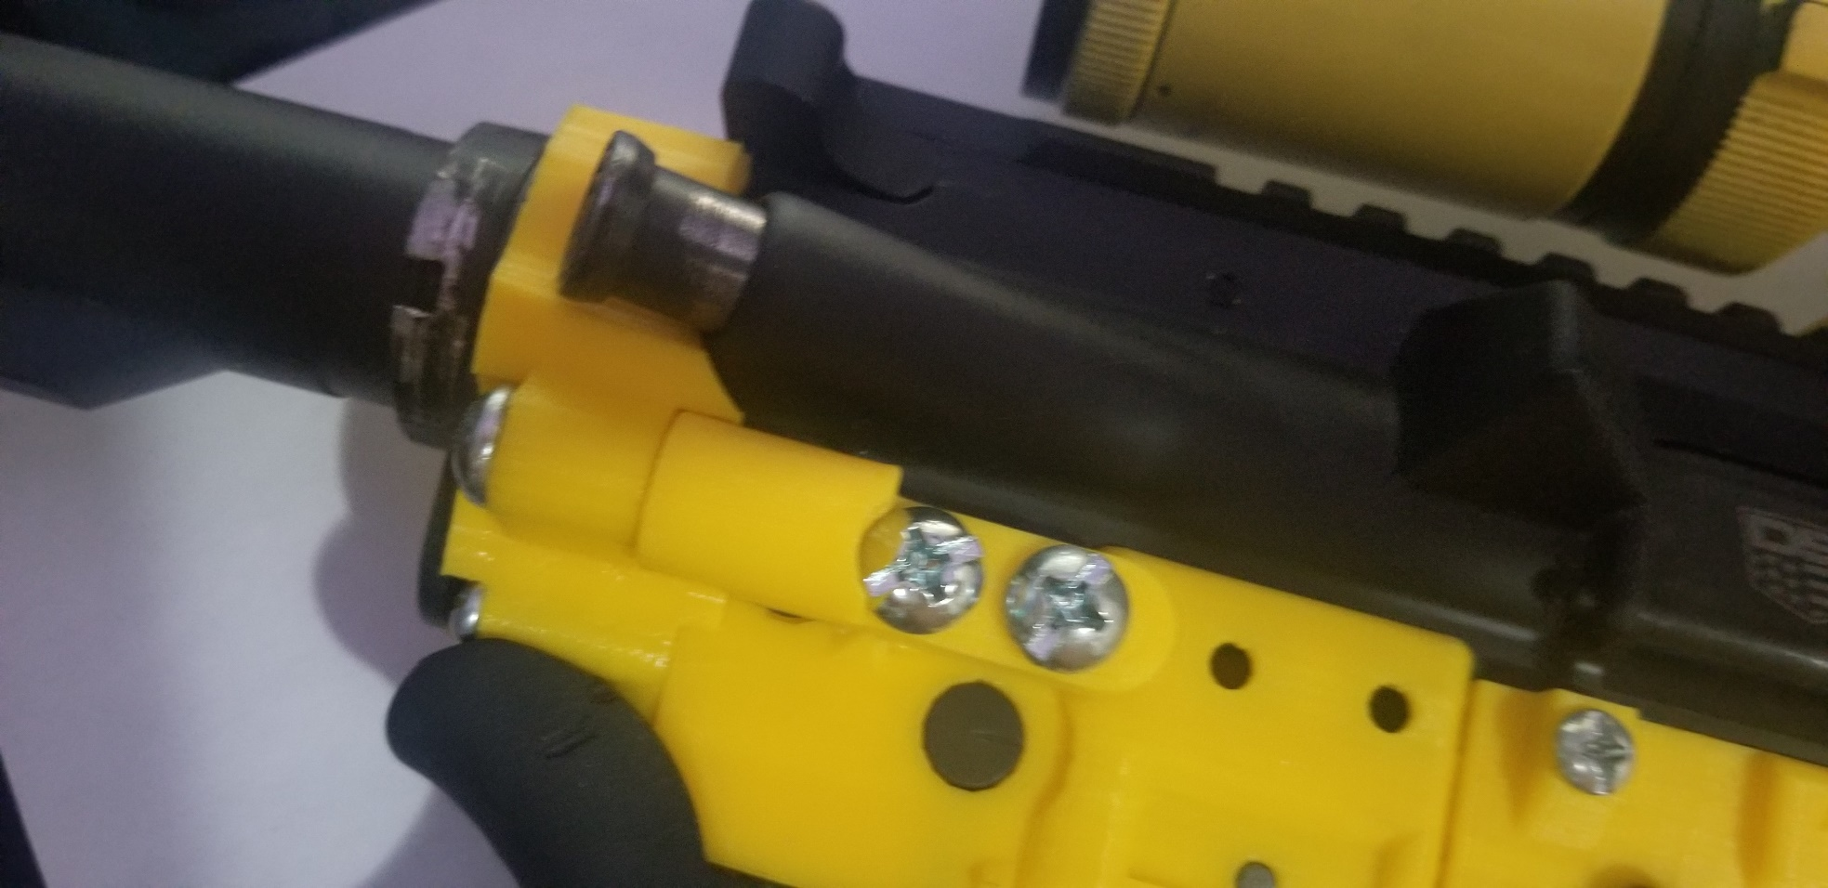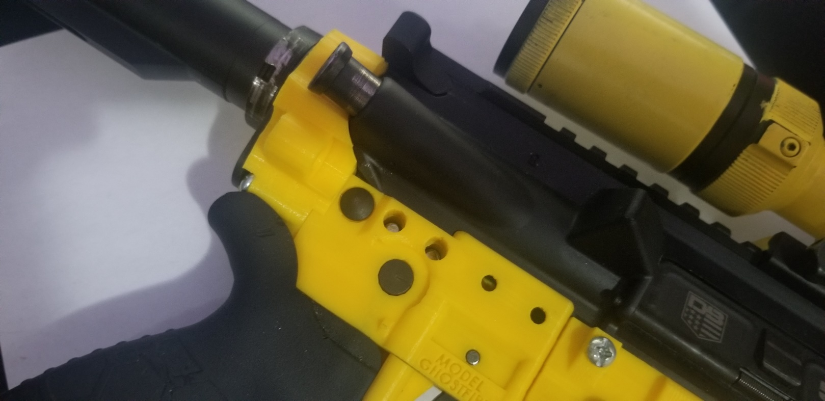

E

D

D

With the takedown pins punched in like shown in the pictures above, you can now install the Buffer to FCG Right Strut using the same screws and procedures as the left.

Implementation

Using the AR-15 is easier than learning to read and write, but this section isn’t about how to use the AR. It’s to highlight certain changes in the manual of arms of an AR-15 caused by the fact that this is in PLA and not aluminum. Im not assuming that you are stupid and know for a fact that you already know how to use an AR. If not, watch some YouTube, its that stupid easy to use.

Heres some changes from a normal lower to note of:

1. In the case of malfunctions, the takedown pins are not easily removable. Learn to remove malfunctions through the removal of the magazine and racking the charging handle multiple times to forcibly eject stuck/fired cartridges and casings. Because field stripping the weapon is impractical, learning the solve malfunctions is far more important.
2. Use the dust cover. To avoid malfunctions, close the dust cover excessively. This is something that is drilled into the military but not the civilian. Closing the dust cover is what makes the AR platform more reliable than the AK (Shocking, I know, but after shooting both AK and AR, the dustcover is literally the reason the AR is more reliable). Since field stripping is difficult on this weapon, the dustcover is your friend to prevent jams.
3. The fire selector is harder to manipulate. This is everything to do with design. I will find solutions to make it easier to use the fire selector in the future. For now, learn to play with the safety to deal with this fact.
4. There are 4 exposed holes on the Fire Control Group. This is intentional and is for future use as two major upgrades: extra struts to attach to the buffer tower, or as an addon mechanism to allow full auto functionality. Keep in mind that full auto is totally illegal, but quite frankly I don’t give a damn. For now, plug the holes if you want to keep debris from impressing into the weapon, while I make the necessary updates to make them usable.
5. The magazine doesn’t always drop out of the weapon upon pressing on the magazine release. This has to do with the magazine having a tight fit into the magazine well and is intentional. What this means is that speed reloading is not practical with this weapon, nor should speed reloading be used in combat anyways. You have to grab the magazine and yank it out once pressing the magazine release to detach the magazine as suppose to relying on it to drop out of the lower. I will work a way to make it drop out smoothly, but so far the best solution from the 3D Printing community is to use acetone smoothing to make the magazine well slick enough to get the magazine to detach fully. However, I have never done acetone smoothing so use this method cautiously as I do not know if it will affect the reliability of assembling the lower.

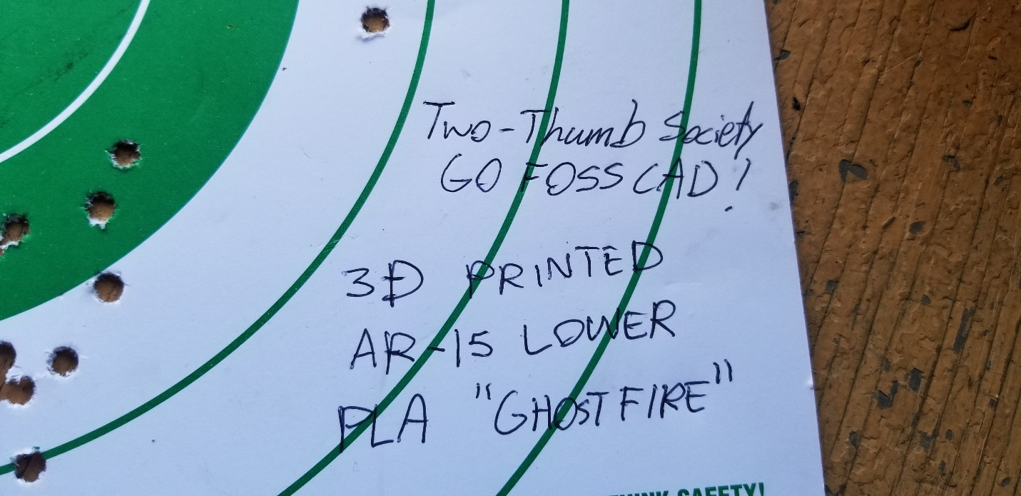

That’s all folks!

Sources and Citations

* My brain and thoughts
* The Fosscad community
* Common Sense
* General research, like google
* Some other source n shit I dunno